|  |
| --- |
| **Software Requirements Specification** |
| Requirements for Version 1.0 |
|  |
|  |
|  |
| **T2A Team** |
| **20/10/2012** |
|  |

# Revision History

|  |  |  |  |
| --- | --- | --- | --- |
| **Creator** | **Date** | **Reason for changes** | **Version** |
| AnhMV | 1/10/2012 | Create draft | 1.0 |
| AnhMV | 20/10/2012 | Update Use case | 1.1 |
| AnhMV | 3/10/2012 | Update images use interface | 1.2 |
|  |  |  |  |
|  |  |  |  |
|  |  |  |  |
|  |  |  |  |
|  |  |  |  |
|  |  |  |  |
|  |  |  |  |
|  |  |  |  |
|  |  |  |  |
|  |  |  |  |
|  |  |  |  |
|  |  |  |  |
|  |  |  |  |
|  |  |  |  |
|  |  |  |  |
|  |  |  |  |
|  |  |  |  |
|  |  |  |  |
|  |  |  |  |
|  |  |  |  |
|  |  |  |  |
|  |  |  |  |
|  |  |  |  |

Table of Contents

Revision History 2

1. Introduction 5

1. Purpose 5

2. Document Conventions 5

3. Scope 6

4. References 6

2. Overall Description 6

1. Perspective 6

2. Features 6

3. Users classes and Characterisstics 7

1. Actors 7

2. Diagrams 7

4. System Enviroments 9

5. Design and Implementation 9

6. User documention 9

3. System Features 9

4. External Interface Requirements 9

1. User Interface 9

2. Hardware Interface 16

5. Other Nonfunctional Requirements 16

1. Performance Requirements 16

2. Safety Requirements 17

3. Security Requirements 17

4. Software Quality Attributes 17

6. Appendix A: Glossary 17

7. Appendix C: Issues List – Change log 17

# Introduction

## Purpose

Duy Tan University (DTU) is located in the heart of Danang, the biggest city in central Vietnam, with many great advantages in terms of climate, location, transportation, and social infrastructure. Danang is also the main gateway to some UNESCO World Cultural Heritages Sites, including the Phong Nha - Ke Bang National Park, the Hue Citadel, Hoi An Ancient Town, the My Son Holy Land, and other natural sights such as Non Nuoc Beach, the Marble Mountain, the Cham Museum and the Ba Na Resort, all of which certainly makes Duy Tan University an ideal place for study and enjoyment.

Established in 1994, Duy Tan University is the first and the largest private university in Central Vietnam. Over the past 17 years, Duy Tan has invested in constructing spacious facilities with five campuses of about 50,000 square meters, ten laboratories and nine workshops, with more than 1,100 internet computers. Duy Tan has become a university with some of the highest quality facilities in Central Vietnam.

Duy Tan University offers seventeen courses to 43,000 students at undergraduates, college and postgraduate levels, which have graduated more than 25,000 qualified students into the labor force. Over 89% graduates got jobs after their graduation. This rate is even higher (100%) for DTU Information Technology students.

DTU’s goal is to become a multidisciplinary and diversified university by the year 2020. DTU lecturers and staff are highly encouraged by the Board of Rectors to do scientific research, which is considered as a basis for quality assurance in educating and adapting to social requirements.

With the above goals. To enhance learning as well as teaching at the University for all students. Duy Tan University had planned to construct a system to pratice programming and algorithmic thinking through the exercises. With the hope that by participating in this software you will find excitement in learning computer science, improve their qualifications, and also can exchange and learning from you!.

## Document Conventions

In general this document prioritizes in writing the schema of the client-server mechanism that takes hold in this project and then analyzing in detail the tools that are available in the iTest editor and question database system. Therefore there are lots of abstractions to represent in a more convenient way the objects and their behavior on the system. Every requirement statement is assumed to have its own priority as to define in most appropriate way the system behavior .In addition there are various figures that represent the described system, where it is needed, and serveonly for better understanding of the deployment. Please refer to the official documentation of the program at <https://code.google.com/p/dt-online-judge/> if you have specific questions based on your system.

## Scope

To produce the software that met all the objects, we have many goals as following:

* Build the website that allow user to user anywhere if they have internet connection
* Website must clearly display the exam.Have attached the file upload function in accordance with standards prescribed by the competition.
* Uploading image is the important function to this website.
* Apply the high level and free technical to produce website
* To release this product in short time, we must use simpler development process. We'll use warterfall process in this project.

## References

This citation is used as a model of reference [**IEEE Std 830-1998]**

# Overall Description

## Perspective

Since this is a open source program it is under the GPL so the source code is free to download. There are various reasons why should anyone use this program.

## Features

The major features this program contains are the following:

Scoring: Students after completed answer a question can know score they have earned.

Scores filter: Show score listing (Top to Low)

Cross platform support: Offers operating support for most of the known and commercial browser.

Language support: Offers multiple language support for global use.

Printting: Offers printting support. User can be printed exam to offline view.

Class diagram

## Users classes and Characterisstics

So simple website, providing the T2A user classes-actors with the 2 following objects:

### Actors

**Student**: Users interfaces in web pages. Students can connect to the web anywhere to participate in the competition were updated at that time. It is convenient to each student represents a user in the system.

**Teacher**: As the administrator of the system. And every teacher updated database questions and identification of options for each test.

### Diagrams

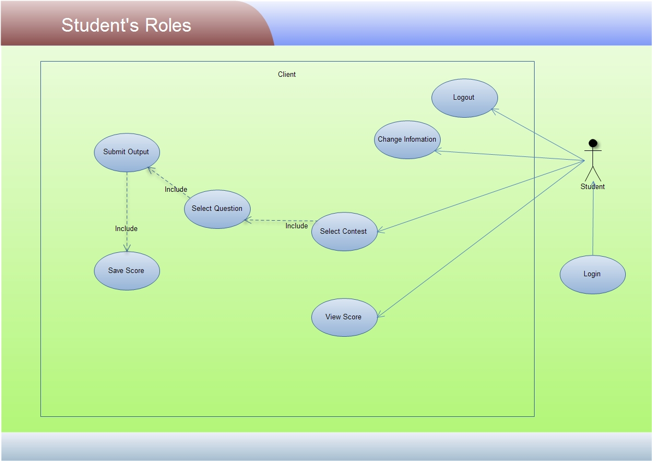

Fig1. Student Roles

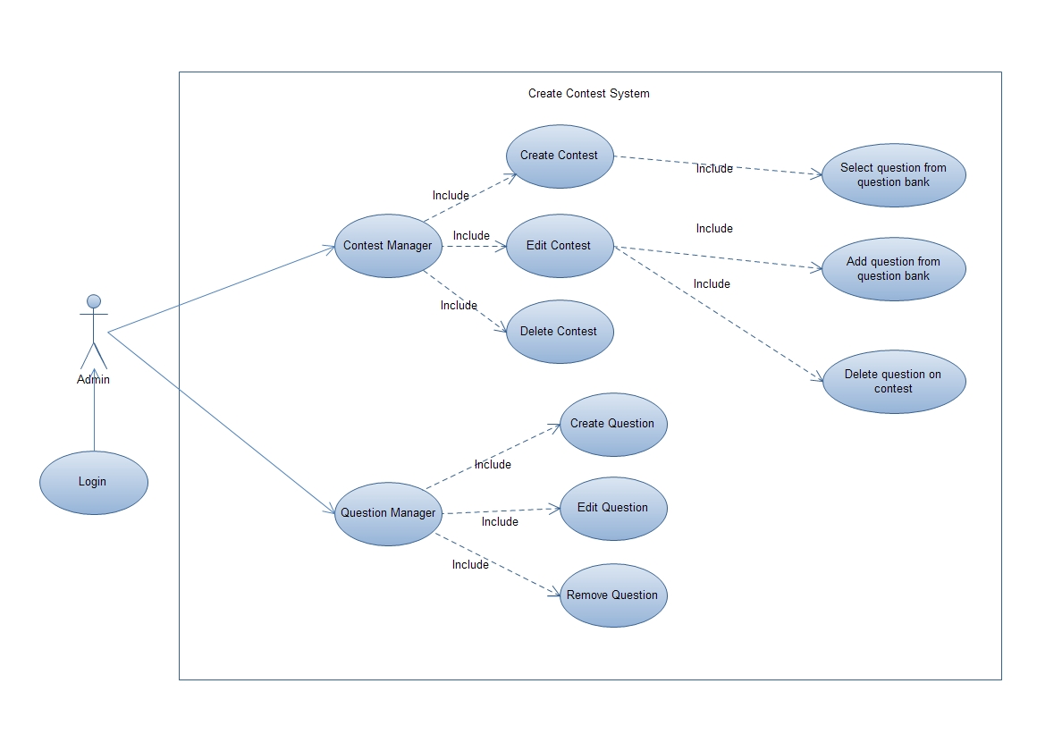

Fig2. Create Contest

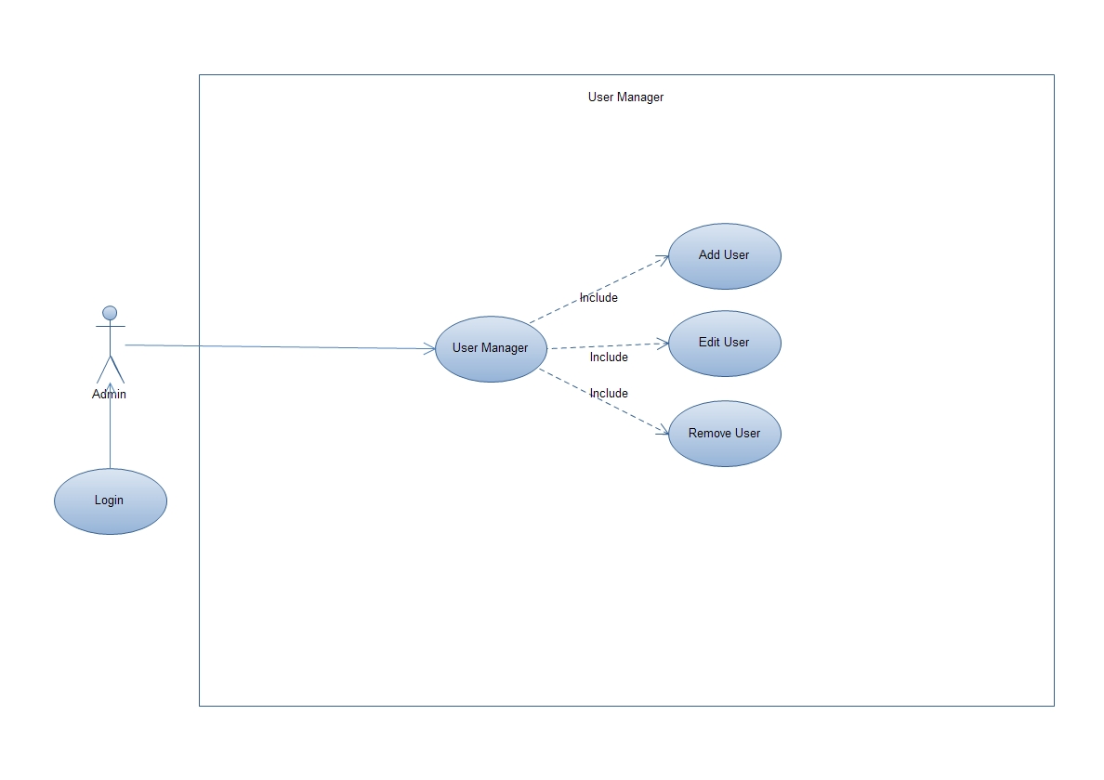

Fig3. User Manager

## System Enviroments

This program will operate in the following operating and browser enviroment for the client and the server.

* Mac OS X ( Safari 10.6.8 )
* Microsoft Windows ( Internet Exolorer 9.0, Google Chrome 22, Firefox 15)
* Linux ( Firefox 15)

## Design and Implementation

This program is created using C# programming language and uses the MVC 3 library for the main and client modules. So a minimum PC having at least 256MB of RAM and CPU over 1GHz is required to run the program with good speed. Also the program uses 20MB of hard disk space to store the program libraries.

A guide is providing to how to step by step install program on server.

For language support except from the basic English language pack there is also a Vietnamese language pack can be enabled within the program.

## User documention

Here are the official links of the project where you can retrieve more information about it and download the latest version:

Online documentation:

<http://dt-online-judge.googlecode.com/svn/trunk/Delivers/>

Official Webpages

<http://dt-online-judge.googlecode.com>

<https://code.google.com/p/dt-online-judge/>

# System Features

Refer to System_Features.xlsx

# External Interface Requirements

## User Interface

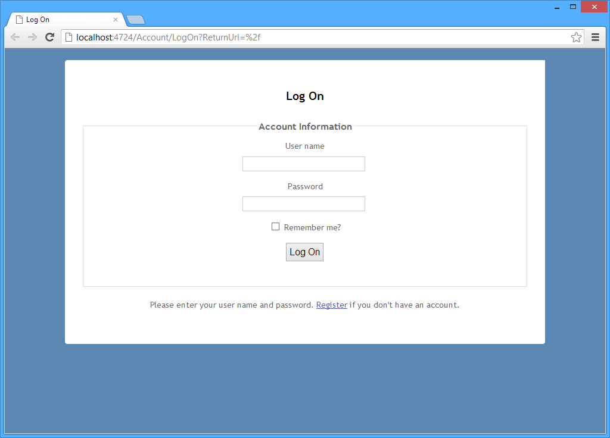

Fig4. User login

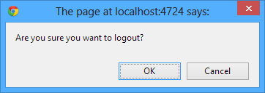

Fig5. User logout

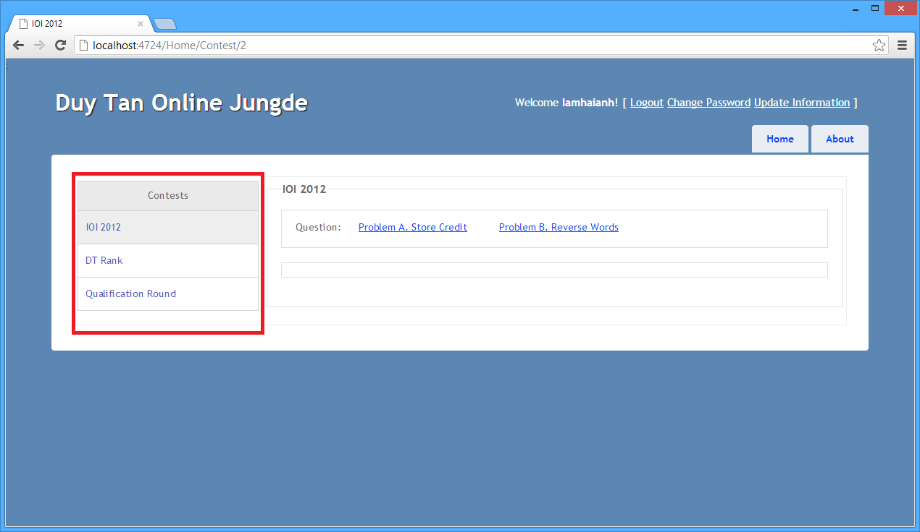

Fig6. User select contest

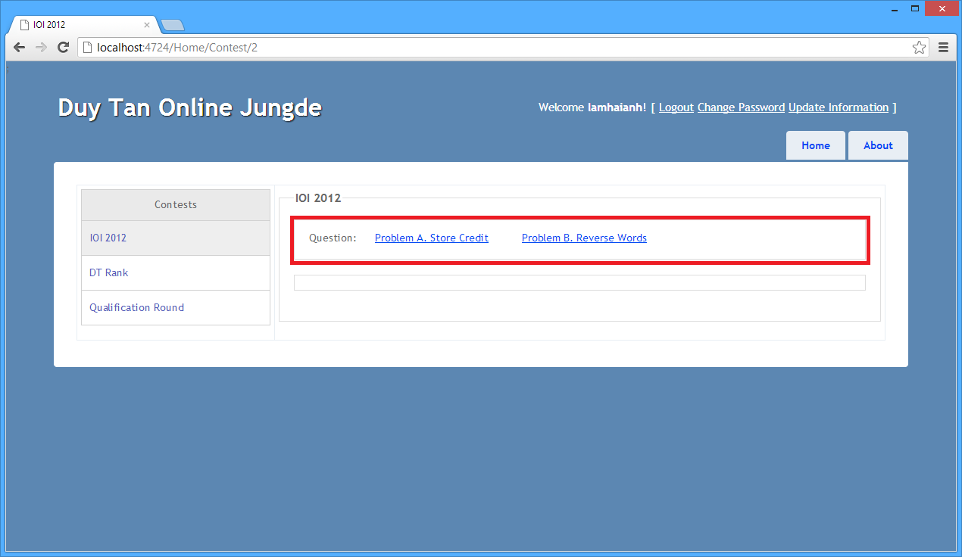

Fig7. User select question

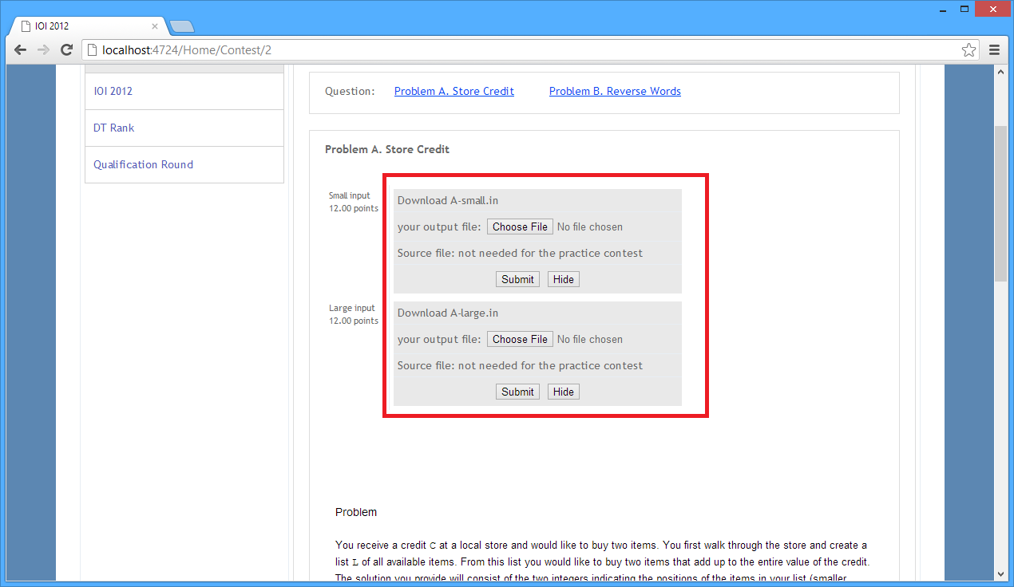

Fig8. User submit output file

Fig9. Return question point after user submit output

Fig10. User view score table

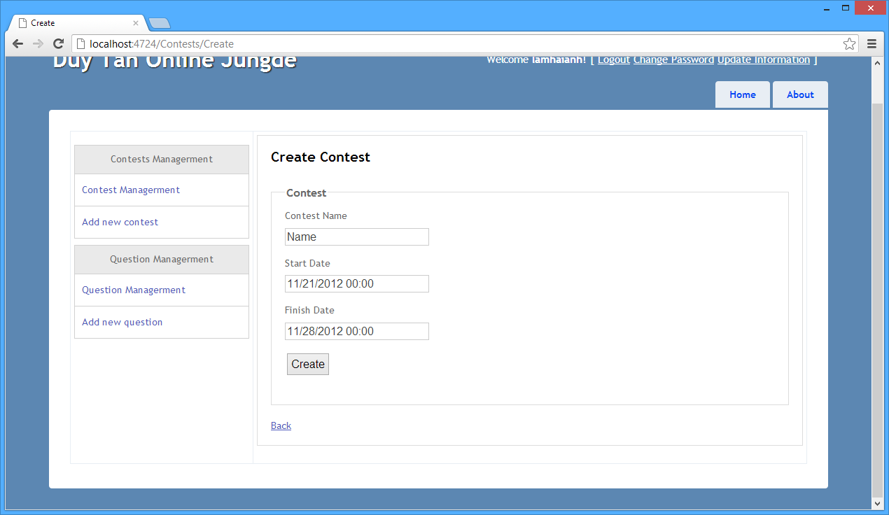

Fig11. Admin create a contest

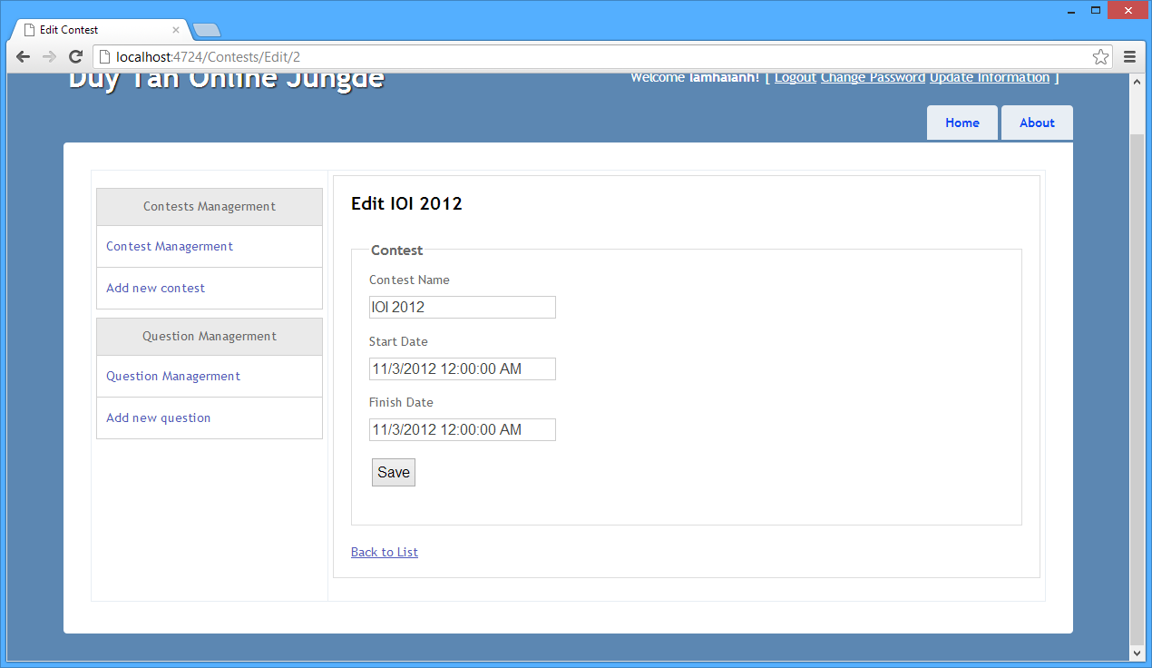

Fig12. Admin update contest

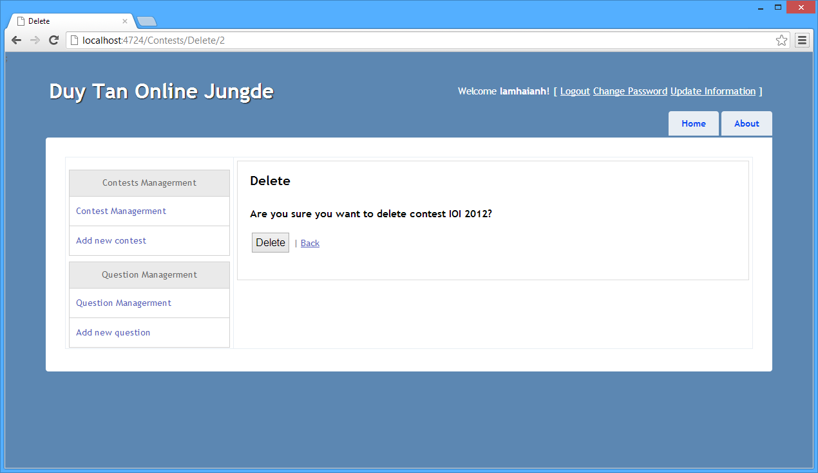

Fig13. Admin delete contest

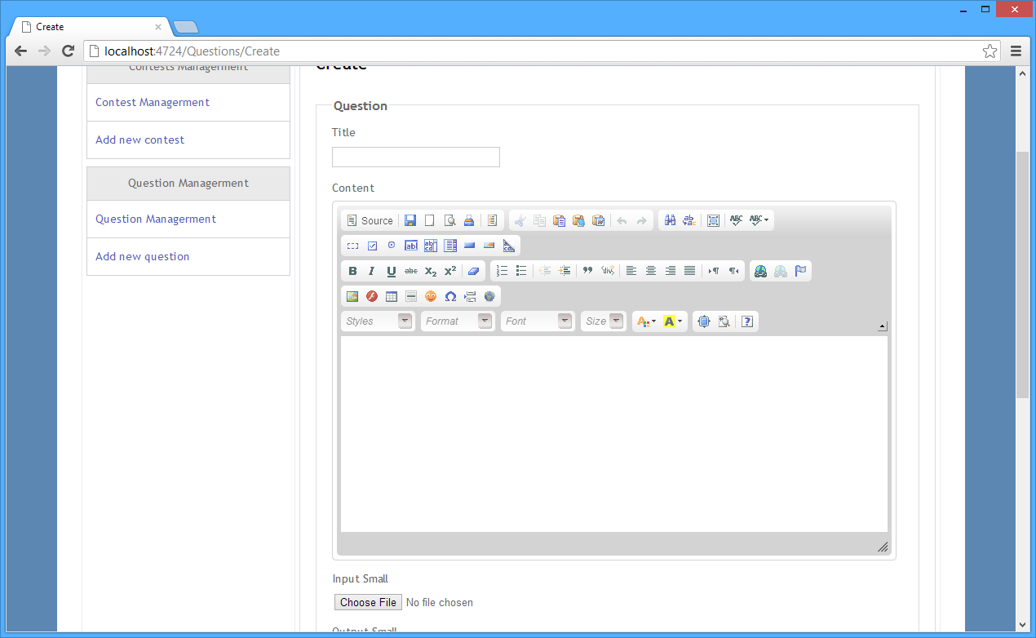

Fig14. Admin create a question

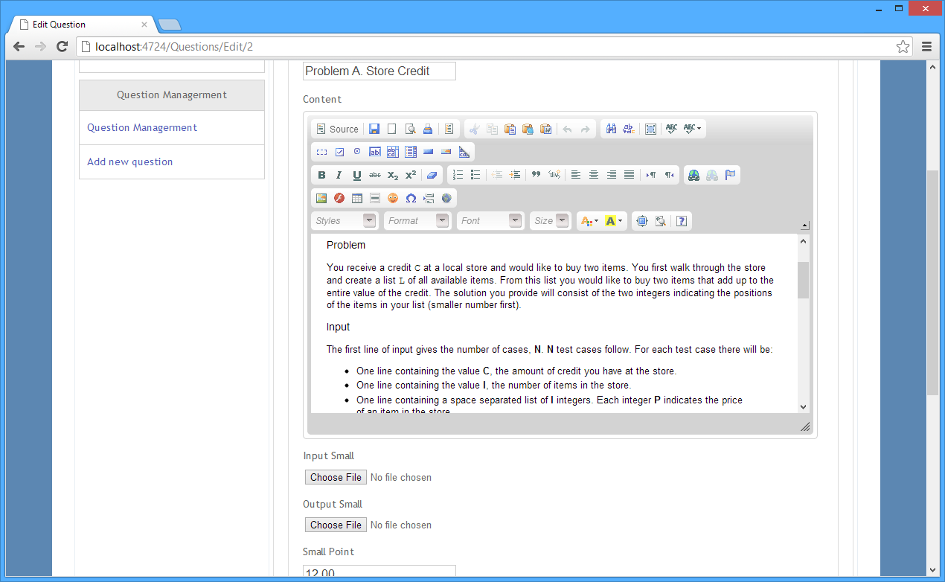

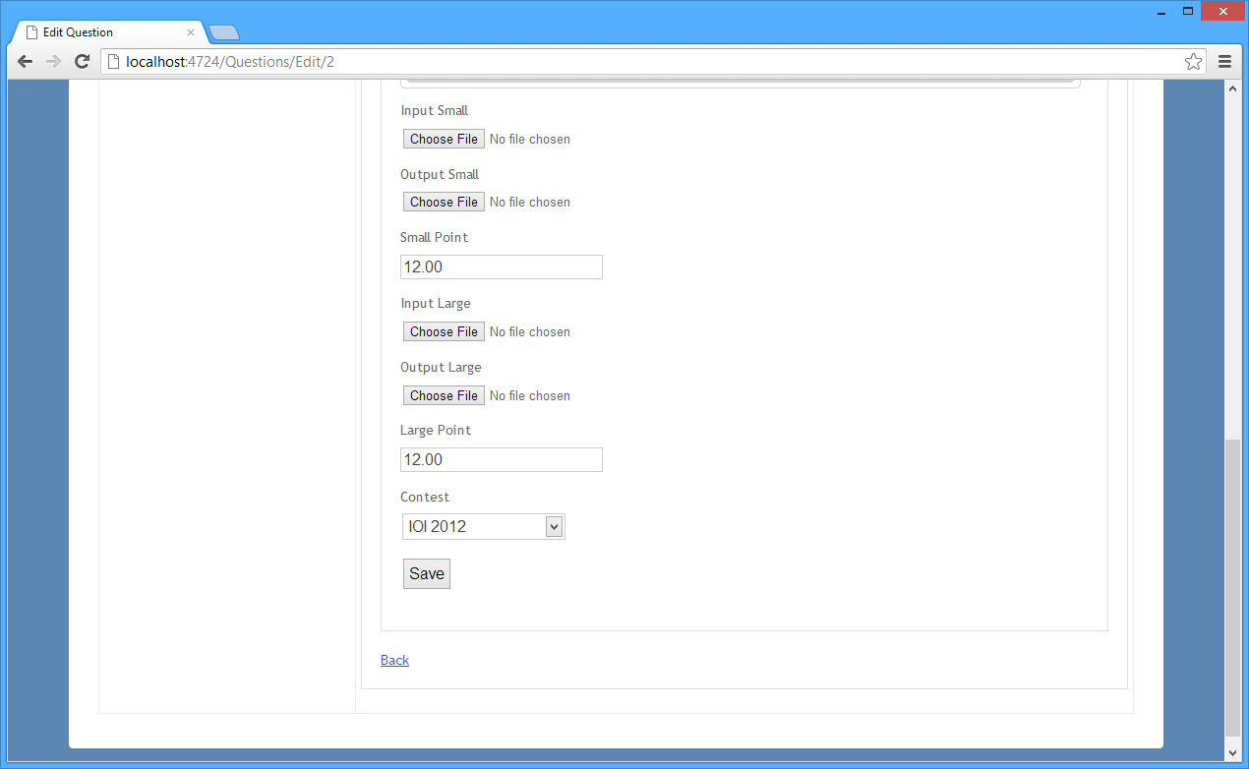

Fig15. Admin update a question

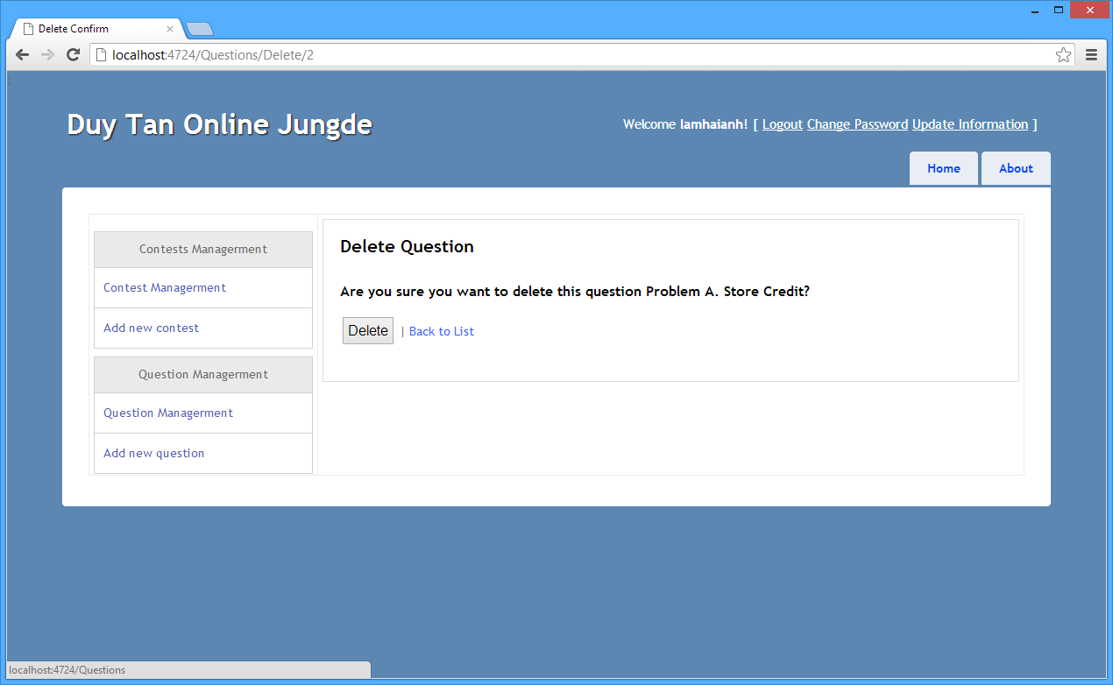

Fig16. Admin delete a question

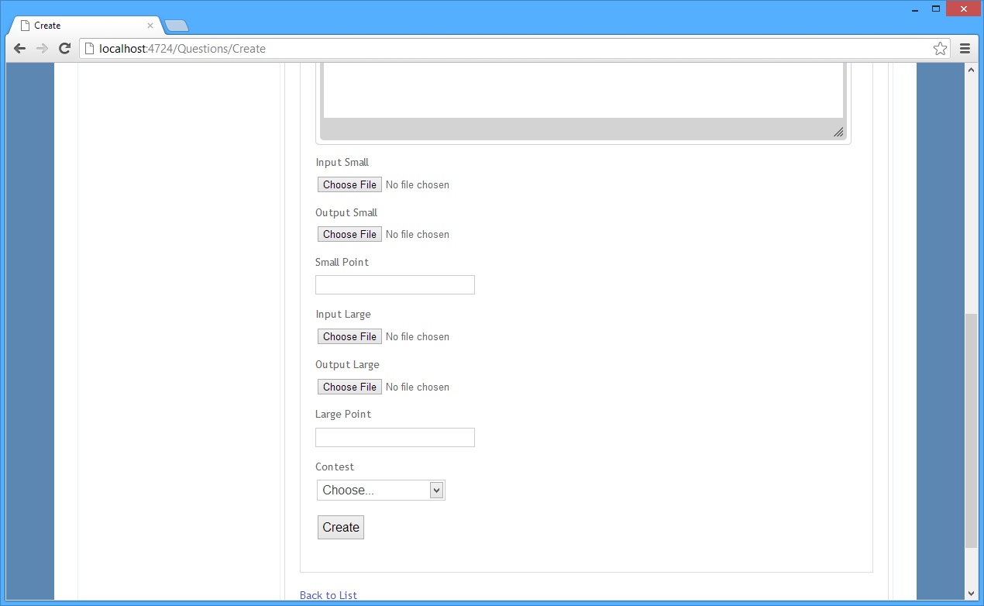

Fig17. Admin send input and output question

Fig18. Admin add a user

Fig29. Admin update information for a user

Fig20. Admin delete a user

## Hardware Interface

# Other Nonfunctional Requirements

## Performance Requirements

They are the users of a system who always want their systems work effectively. Moreover, it is necessary to work stably and fast with an online system. The databases and the sources of information use on website must be arranged suitably to satify the needs at the moment   
and don't have any errors such as the information was blocked, users can't load the file on the website. It should take less than 3 seconds to complete a request. Besides, the link from the PC which sends the request to the server demands on the speed of the line, the distance and the configuration of the computer so the limited time for an online request is from 20 to 30 seconds.

## Safety Requirements

It is an online system which has many test so that it have to be constant. The users always connect to the server in order to update the information and send their answers to the server. In case, the connection has error, there will be a step checking the connection before sending a file to the server. if the connection is OK, the answers will be send immediately.

## Security Requirements

It makes sure the personal information of the customers that the password will be ncrypted by MD5 encrytion. It will be refused when toxic and invalid files are uploaded.  
The system acetp only one kind of file as a text ASCII file, and the file must have a extension which is ".in" or ".out". In addition, any other files will be refused.

## Software Quality Attributes

**Available attribute**The system will check the transmission and web components regularly. If one of them has any problems, the notification of that current errors will appear.  
**Possible attribute:**  
The system makes it easier and simpler for customer, ensures the best satified ability and he consecutive communication between customer and the server.

# Appendix A: Glossary

# Appendix C: Issues List – Change log